**Basic Process:**

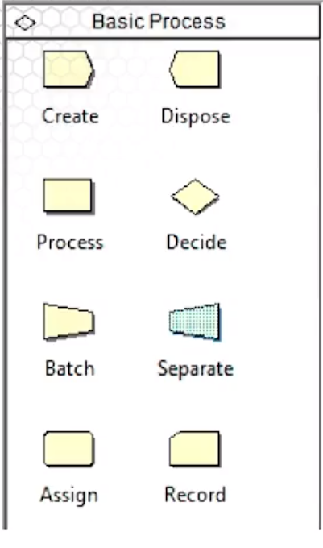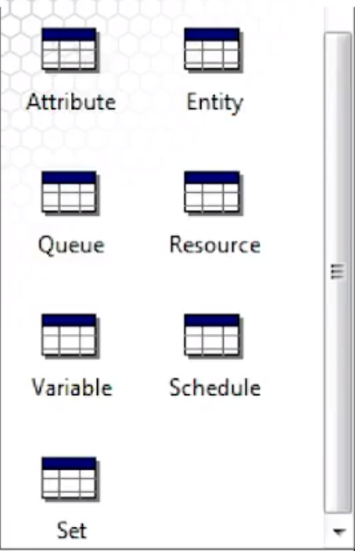

1. Create Module : generate customer arrivals. It includes: Name of the module, Type of entity/customer , Interarrival distribution: schedule, constant, expression, random(expo), Number of customers per arrivals: integer number, POIS(3)+1,build expression to customize. Maximum of arrivals . First arrival

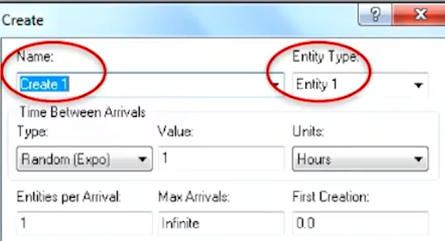

1. Process Module: have work performed on the customers, maybe have to wait in line. 3 actions can happen here: seize(grab server),delay(use server) and release(let the server free). The process’s name “Process 1” will include the resource as well as a default queue called “ Process1.Queue”

If I need to use 2 barbers, set resources quantity=2 here. This is different from setting the resource capacity which is number of barbers available for the entire system = 5

* + - 1. Delay: spend time in the process (self-service)
      2. Seize- Delay Release: grab the server, spend time in the process and free the server for the next customer. If you Seize and the server isn’t available, then a QUEUE is form.
      3. Seize-Delay: grab at least one resource and spend time getting served. Remember to Release sometime later else gets deadlocked and giant line form. 🡪 how to fix the giant queue line: add another parallel process “delay-release”
      4. Delay-Release : use a previously Seize’d server for a while and then free him for the next guy to use.

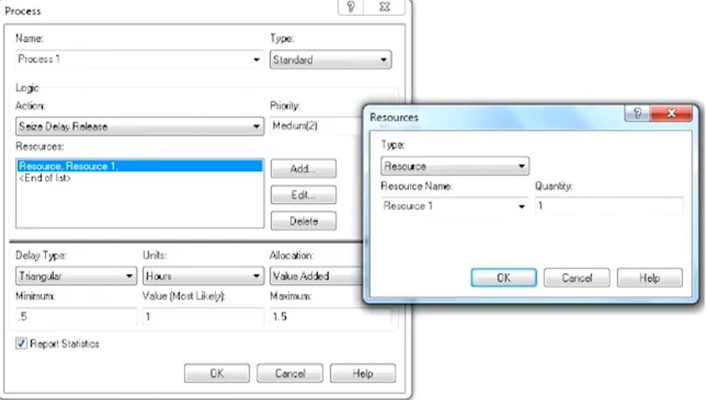

1. Dispose: customers leave the system
2. Decide: allow customer to make the decisions, looks like a diamond
   * + 1. 2-way by chance

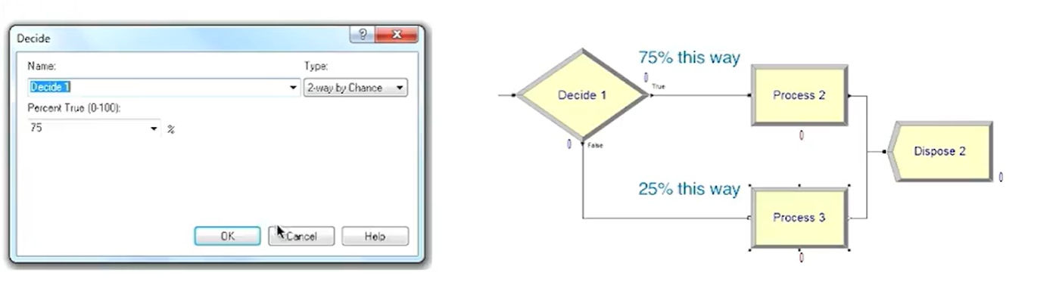

* + - 1. N-way by chance
      2. 2-way by condition
      3. N-way by condition : if customer type==1 to go exist 1. If customer type==2 go to exist 2

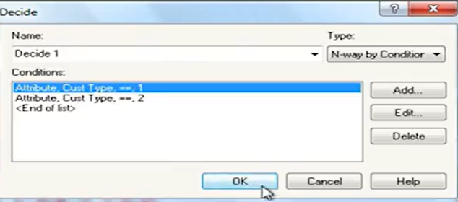

1. Assign module: Why we need assign module?

Attributes/properties are varied based on the customers. Such as height, weight.

Variables, unlike attributes, whose values are specific to customers, variables are global. When you change a variable anyplace in the program, it gets changed everywhere.

We use assigned module to change attributes, variables and other stuff.

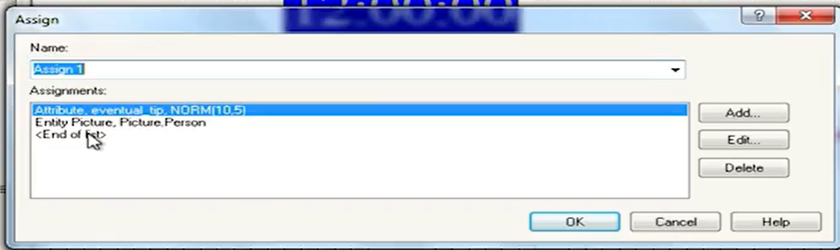

Example of assigning tip value to each customer 🡪 use this attribute as the order for queue. Below is the queue spreadsheet

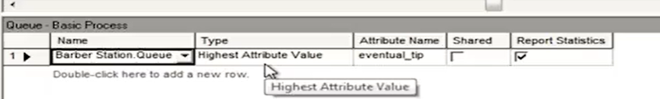

1. Batch module: combine multiple customers into a “ super customer” ..

Ex: batch size=3 means accumulating 3 guys before sending off the super customers. Info about the individual customer in a batch won’t be needed later on then choose type=’Permanent”. If needed, type=’temporary’.

Temporary batch will need to be *split before being Disposed*

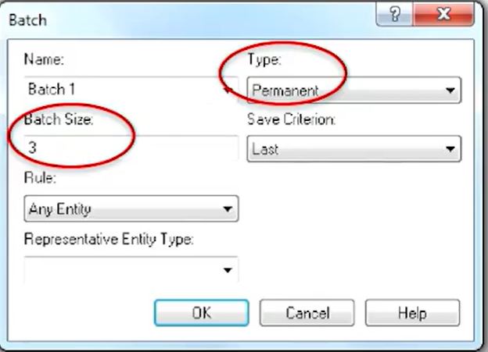

1. Separate Module: duplicate a single entity or split multiple entities that had been combined in a Batch Module.

If the batch = permanent, then splitting will create several customers with the same attributes

If the batch= temporary, splitting will reproduce customers with original attributes

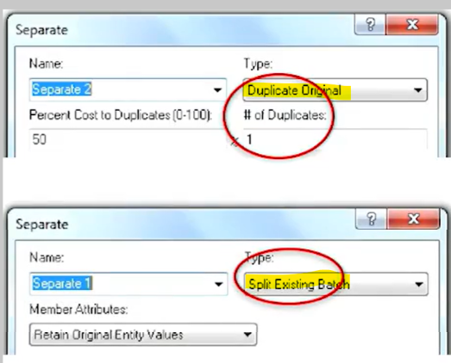

1. Record Module: collect statistics when an entity passed through the module.

**Spreadsheets** : entity, attribute, queue, resource, variable, schedule and set that are both information and allow change made for certain system parameters.

* 1. Variable spreadsheet : defines global quantities such as WIP that are updated as simulation progress. As the guy show up, WIP goes up. As the guy leaves, WIP does down.
  2. Resource: keeps track of the names and capacities of the different resources(servers). Capacity is the number of resources on duty, not necessary the number of server/resource that customer requests. Resource is identical and interchangeable; it can be specified. Resources are automatically added to the spreadsheet when you define them in the Process module.

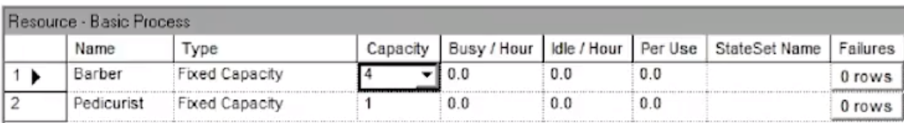

* 1. Schedule Spreadsheets :When capacity is not fixed capacity , we have schedule spreadsheet. See how resources spreadsheet change its type.

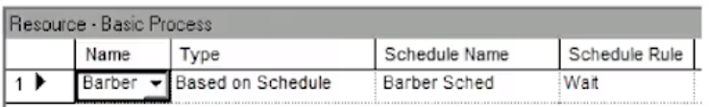

You now can go over to Schedule Spreadsheet and adjust the durations.

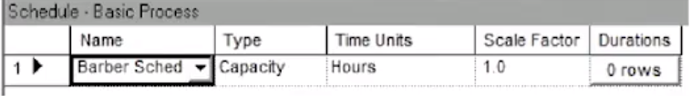

You can also adjust the “ create” module to arrival type “ Schedule” and similar to above, go over to schedule spreadsheets to see it is there

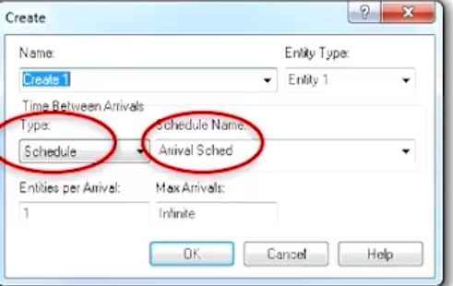

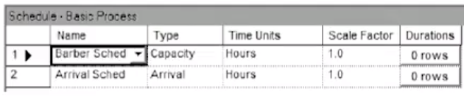

* 1. Queue Spreadsheet: created as soon as there is a Process Module is created., name as “ ProcessName”.Queue

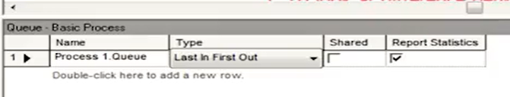

* 1. Attribute spreadsheet: keep track of existing attributes that you might define in an Assign Module.

When you set the attribute for each customer such as below ( cust type 1, 2, 3) using assign block.

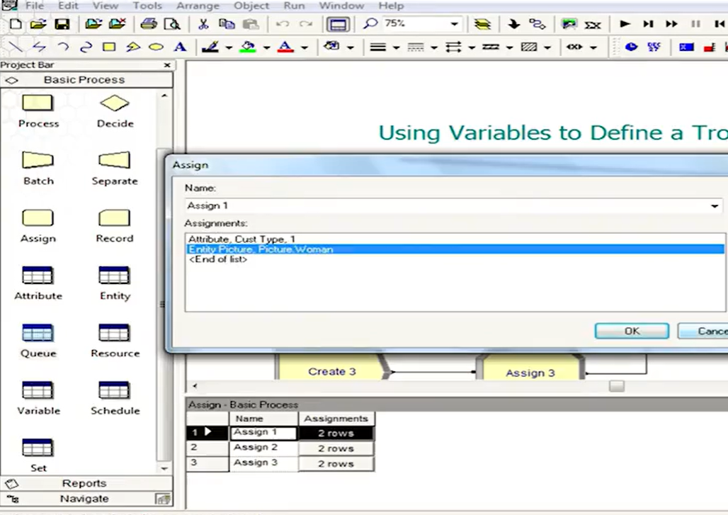

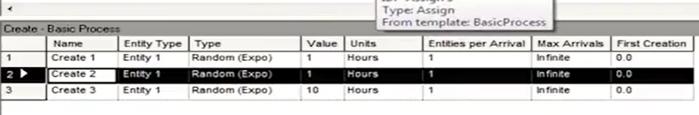

And the example is for the truck to have longer service time. So, we set attribute=”custype”. Then set a variable “mean” and assign the service time based on “ mean-custype1: 0.3” as the vector value. View in the process module

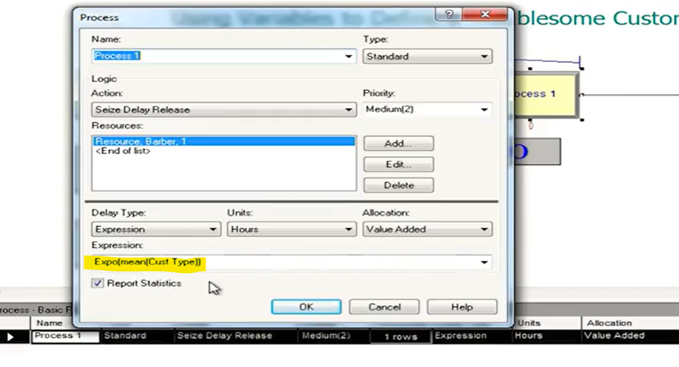

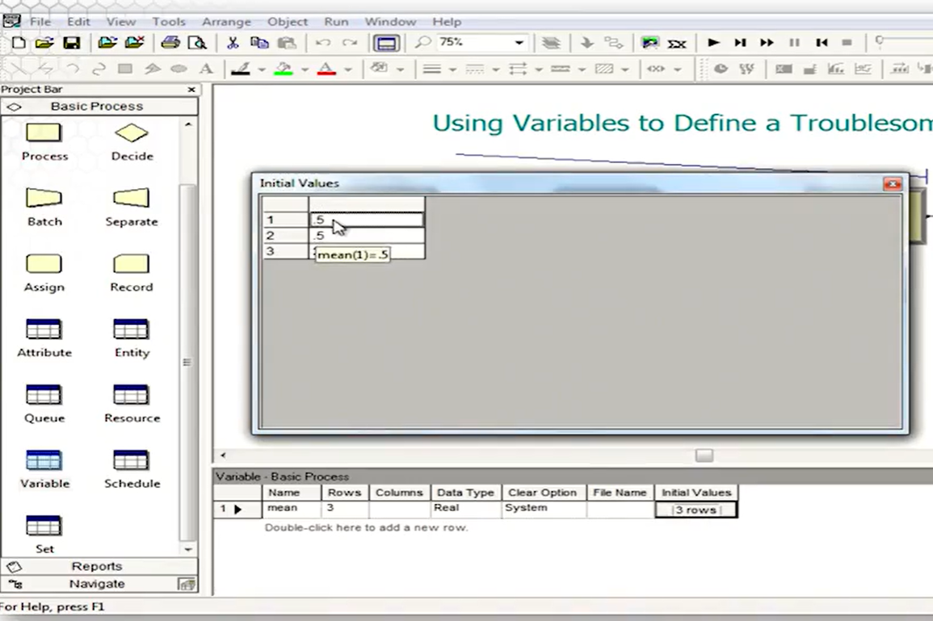

* 1. Entity spreadsheet; allows you to set initial picture.
  2. Set Spreadsheet
  3. Internal Variables: automatically update and calculated as the simulation proceeds . Few important variables:

TNOW= current simulated time

NR(barber): number of resource Barber’s server now working, not necessary all resources

NR(Process1.Queue): # of customers in queue for Process 1

Create1. Numberout : # of customers who have so far left the create module named “ Create1”

Example when using internal variables to build an expression for a decide module

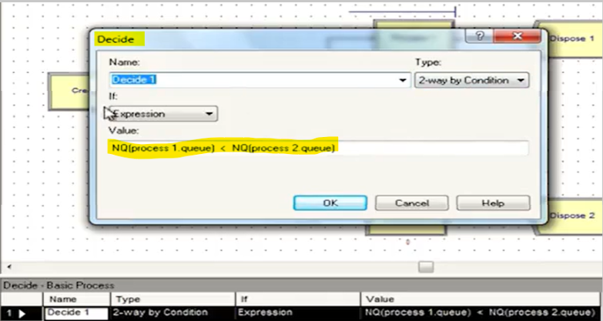

1. Display information and results for the simulation: digital clock, calendar, variable displays to keep track value of variables in real time, histogram, graphs and generate output reports to give info about server usage, queue length, customers waits, cycle times and other user-defined quantities.
2. Run set up control:
   1. Replication parameters:

Number of reps: # of independent runs

Initialize between reps: do you start the stat collection or system state from scratch for each replication.

Warm up period: how long to run before you start keeping data

Rep length: how long each run is?

Terminating condition: any special way to stop the simulation.

* 1. Run Speed Tab: adjust the speed of the simulation.
  2. Reports: different reports : Contains info such as lengths of queue, server utilization etc... or Category Overview summarize all reps or by each replication. SIMAN reports give concise text file.

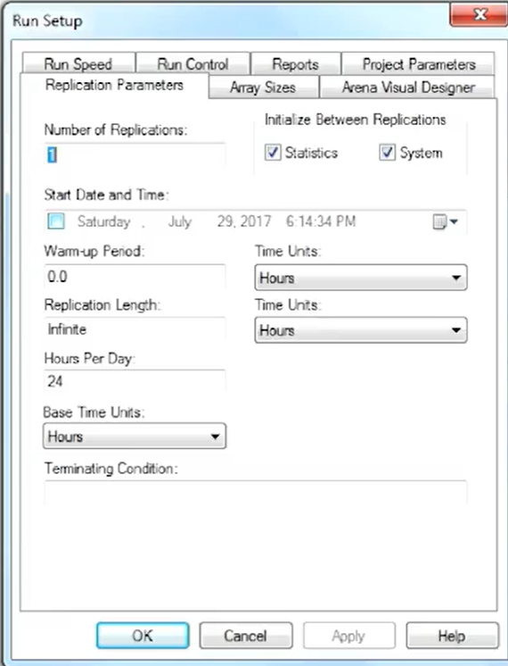

* 1. Run Control: batch mode ( turn off all graphics and result in extremely fast runs)

Module 5: Modeling 2 channel at services

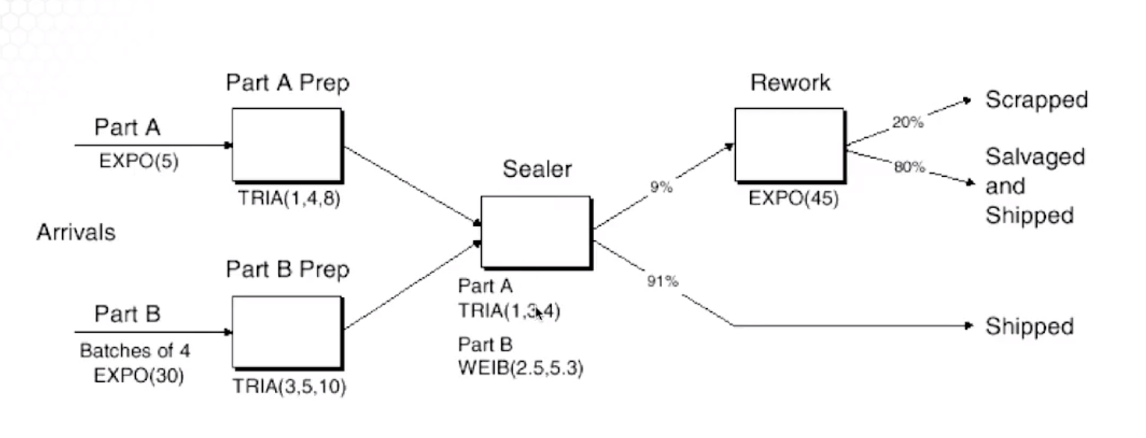

How to handle 2 different service time at process Sealer?

1. Trick 1- Assign Module: assigned an attribute ( “ Sealer Time”) for each customer arrival.
2. Trick 2- Assign module: Calculate service time . Record arrival time under attribute for each customer, use TNOW variable from Arena.

Record departure time just before being disposed. This will let us calculate the agerage cycle time (departure-arrive) for any of the 3 parts ( pass on 1st try, pass on 2nd try, disposed)

1. Without using Assign Module, using logical expression at the process module ( “ Sealer Process”) based on the entity types generated from Create Modules.



Fake Customer

Record module: generate arrival as usual and use record block to count number of observations.

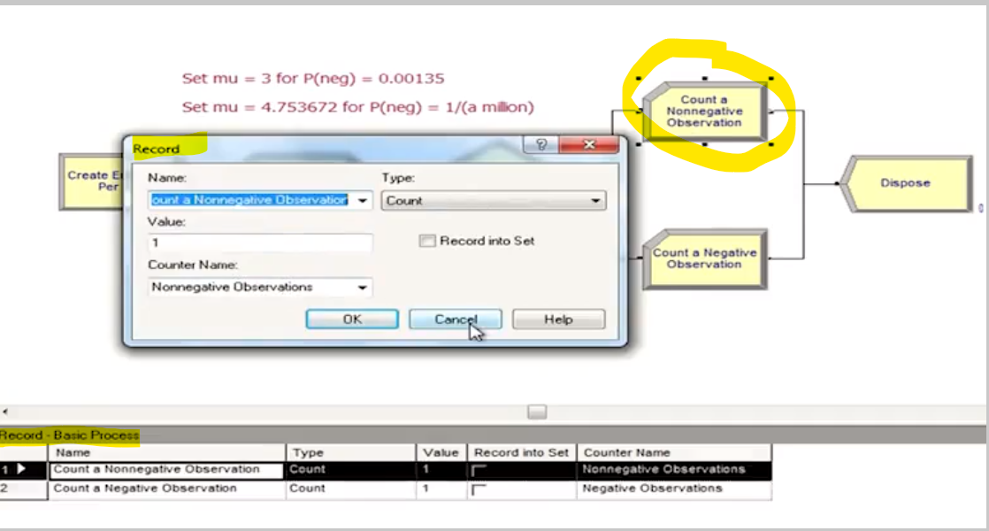

**ADVANCE PROCESS TEMPLATE**

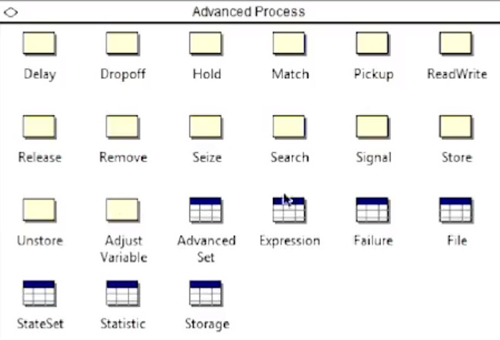

**3 Modules : Seize, Delay , Release**

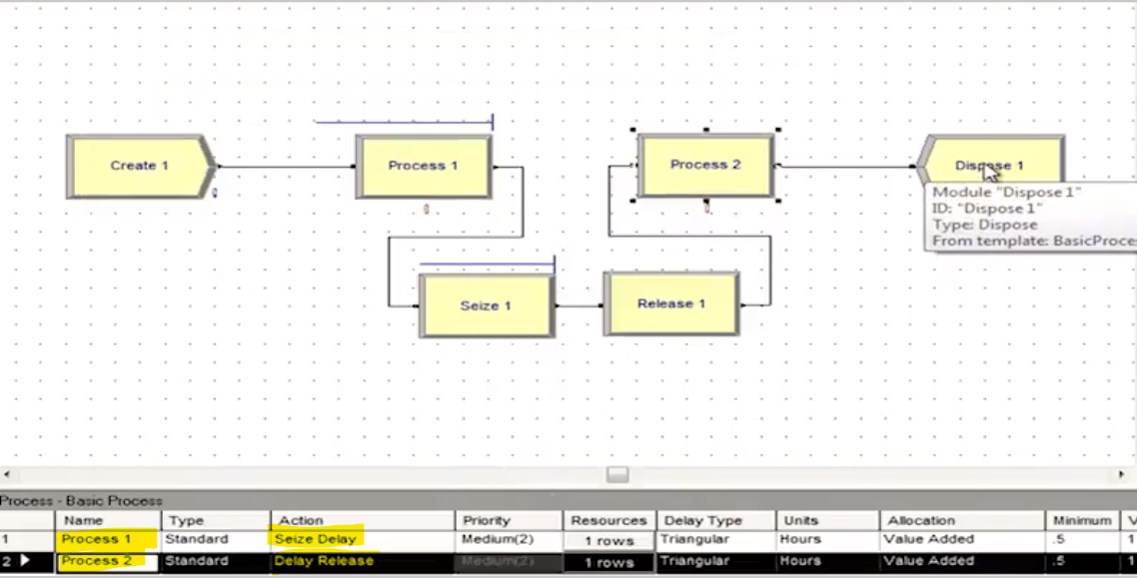

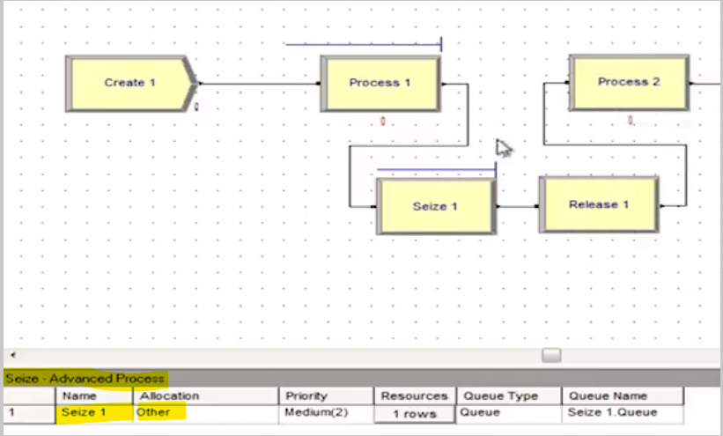

Process 1 is only seize delay, no release.

Seize 1 is for process 2. Comes w/ its own queue.

Release 1 is for process 1. So no line will be ever at process 2 due to seize 1 needs to happen. And the process 2 is delay release, no seize needs.

**Spreadsheet Failures** in conjunstion with the Resource spreadsheet: fill in the Failures column from the Resource basic process then go to Advance template- Failure spreadsheet to fill out details.

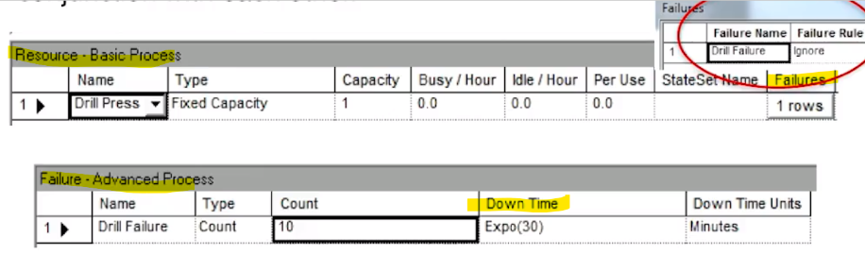

Type of Failure Rules:

* *Ignore*: complete service of current customers, but *reduce* repair times. Example: If repair time is 1 hours and I need 10min to finish the current customer, then repair time gets reduced to 50 and finish at 60 min mark as scheduled.
* *Waite*: complete service of current customer and delay repair. If repair is 60min and current customer needs 10 mins to repair, then continute fisnishing customer and start the repair. The repair will finish at 70min mark.
* *Preemp*: stop service of current customer but complete service after the repair. Ex: repair stops at 60mon mark and finish customer at 70min mark.

**BLOCKS template**

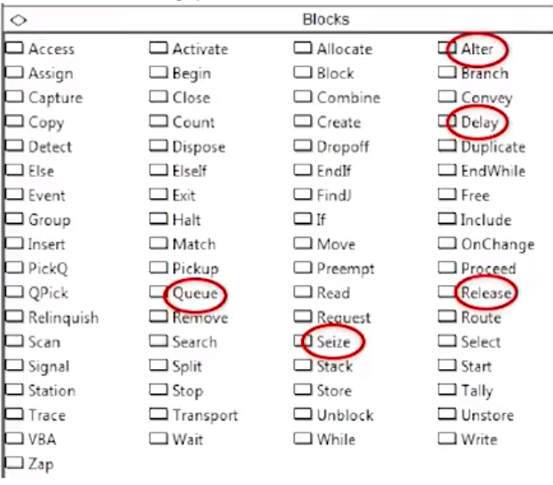

Queue block: being seperated block, set its own capacity. It is the only place where it can connect to the Seize block.. the seize within a process module in the Basic template or Seize in the advanced process template can not connect to this Queue block.

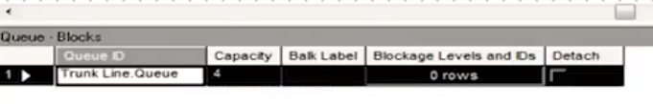

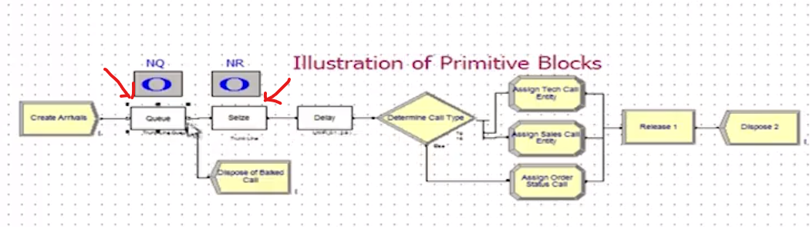

Using Queue block then you stuck at using seize block seperatedly behind it.

**ALTER block**: adding/subtract additional resources/server.

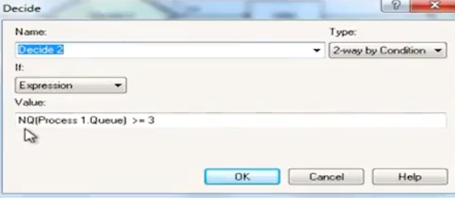

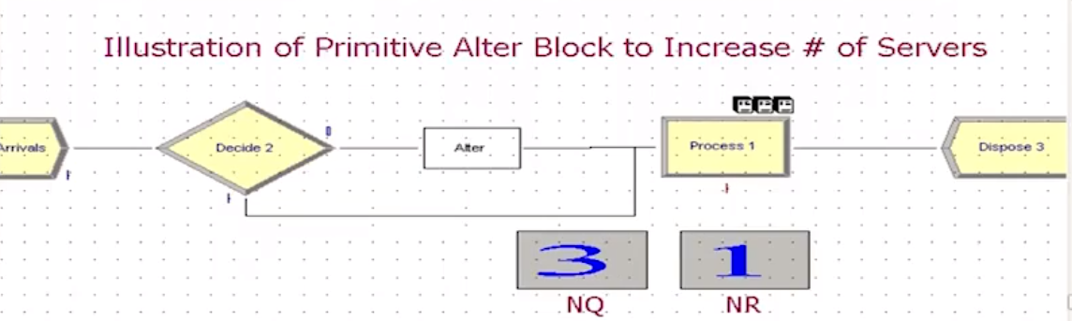

The condition is once the nq length greater than 3 then alter will add a resource. The NR( number of reserouce in use) will increase to 2 while NQ reduce by 1 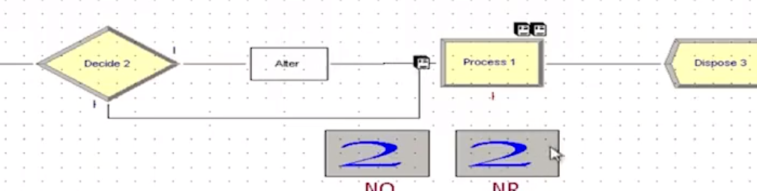

**SETS spreadsheet.**

Definition: a group of elements. Elements can be long to more than 1 set.

Elements mean a lot of thing in Arena. , such as: resources, tally, entity type…

Resource Sets: using SET spreadsheet in Basic Template.

“ Vanilla” resource has itentical interchangeable servers. But a *Resource set can have distinct servers* w/ different schedules, speed, specialities..

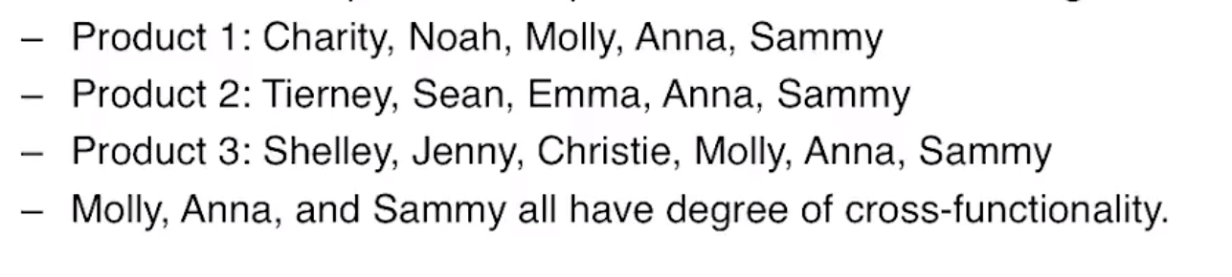

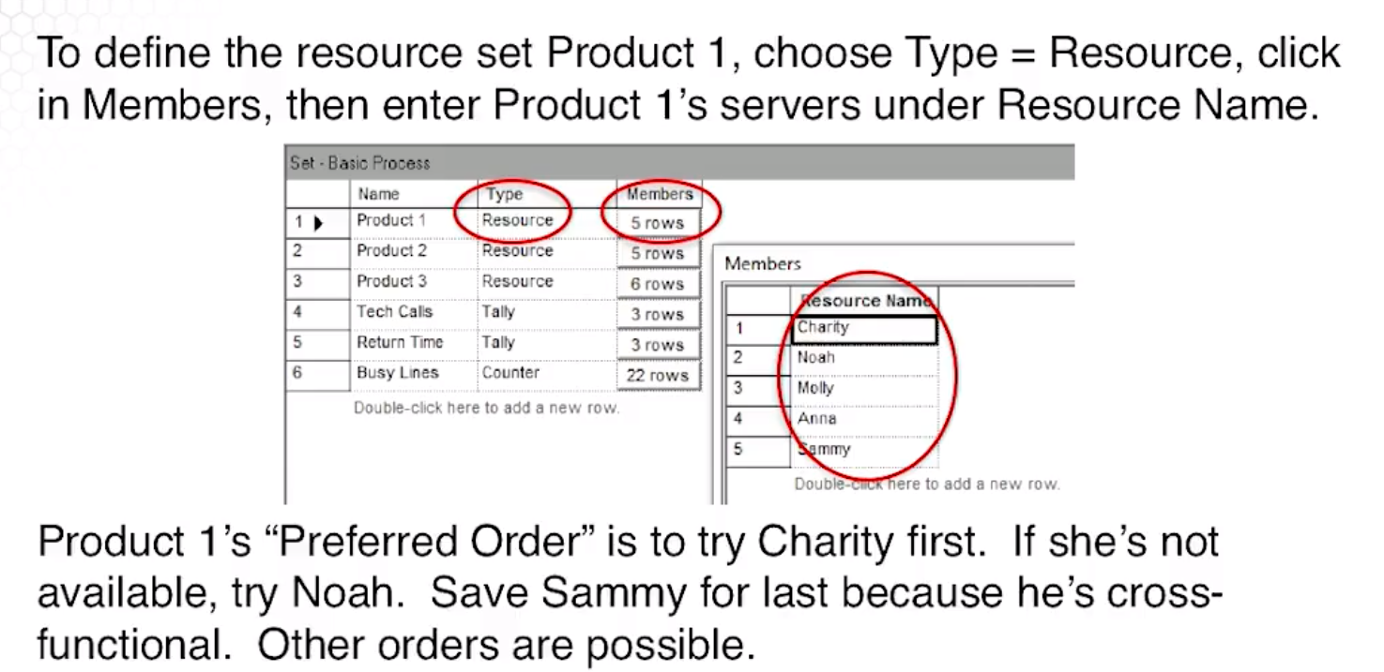

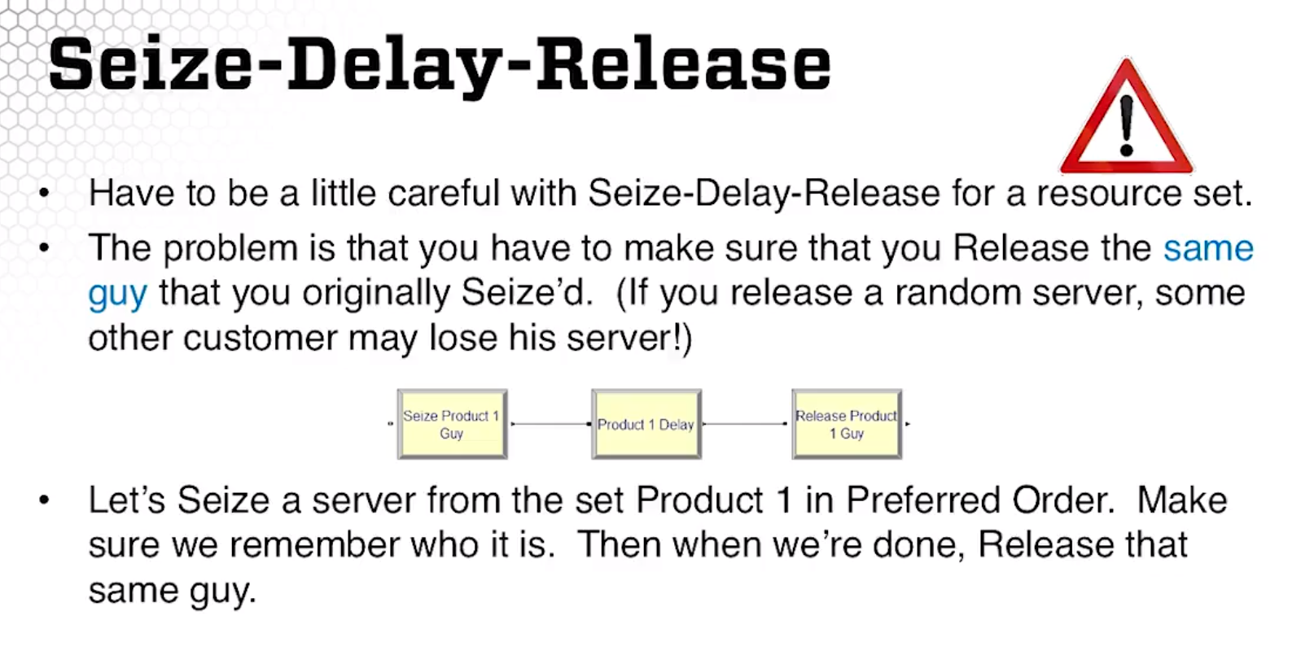

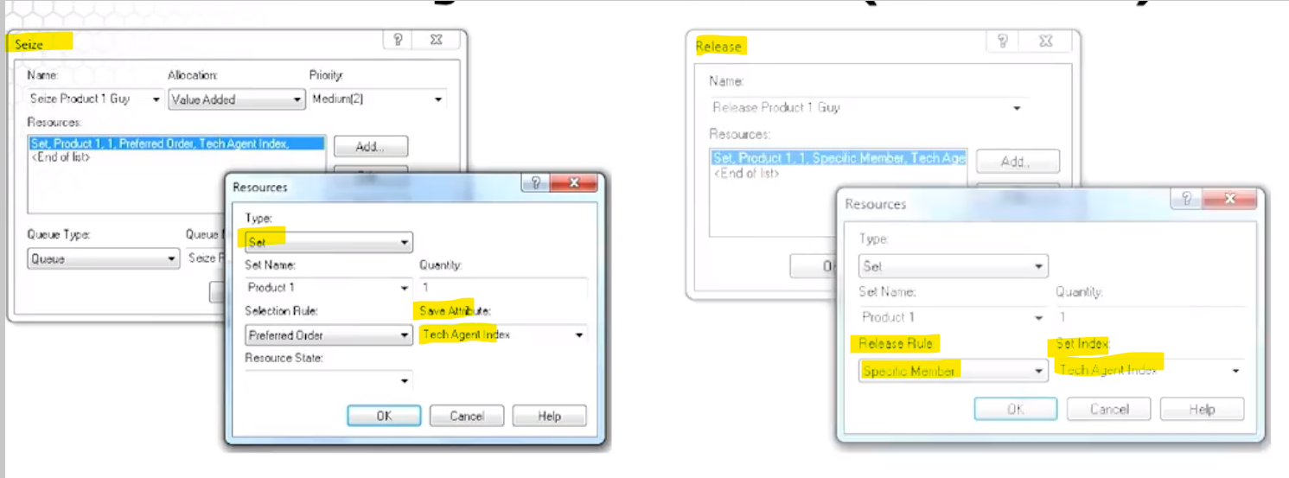

Here we SEIZE a resource from SET, so we have to define the seize selection rule,including: preferred order, specific member, cyclical, random, largest remaining capacity.

When we release, we release rule is specific member.

Here is the screenshot of SET spreadsheet

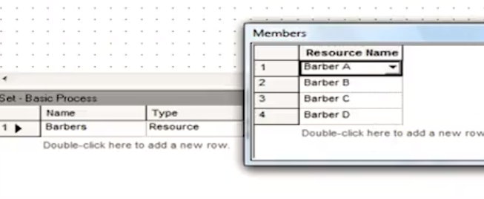

In the Seize block saying I seize the Set, called Barbers, 1 server. I want the server being selected in the Preferred order and store it in the Barber index. Queue is automatically created when Seize block being used.

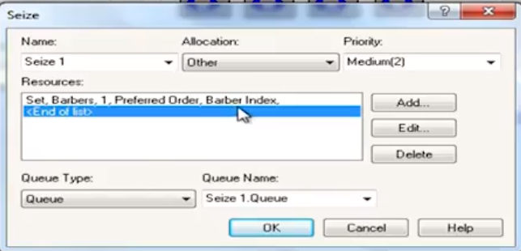

Here is the release module : **BECAREFUL of who and** how you release the resource

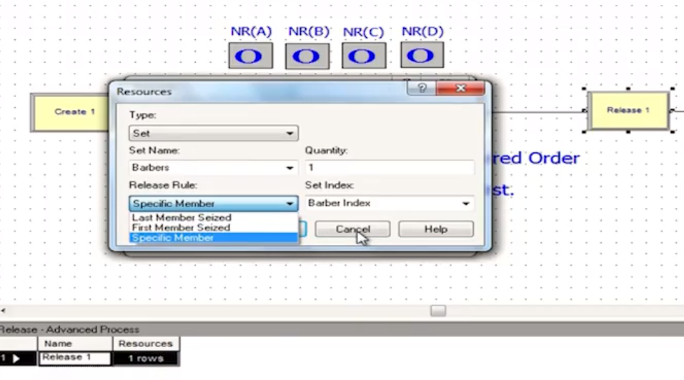

**CALL CENTER DETAILS**

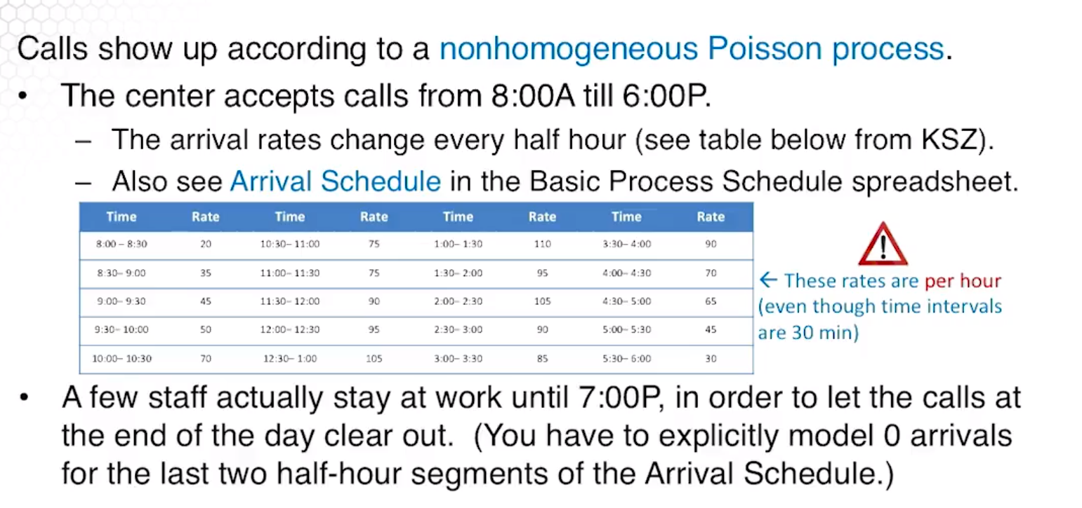

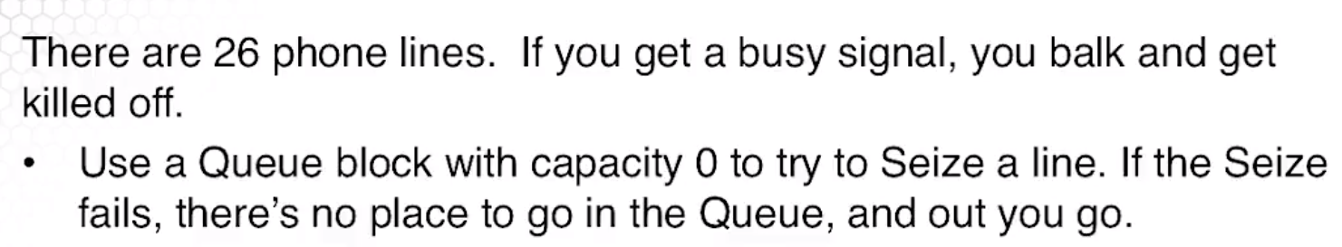

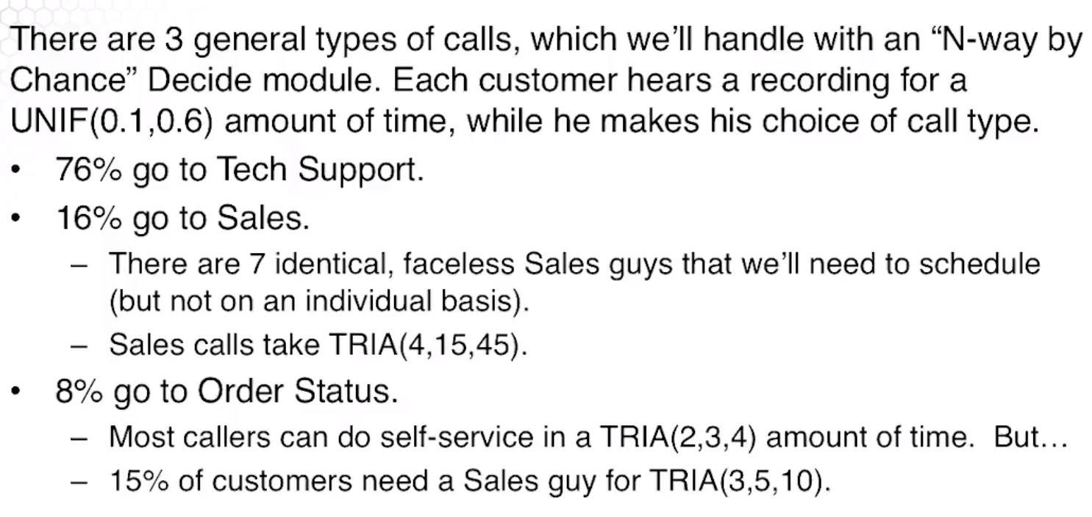

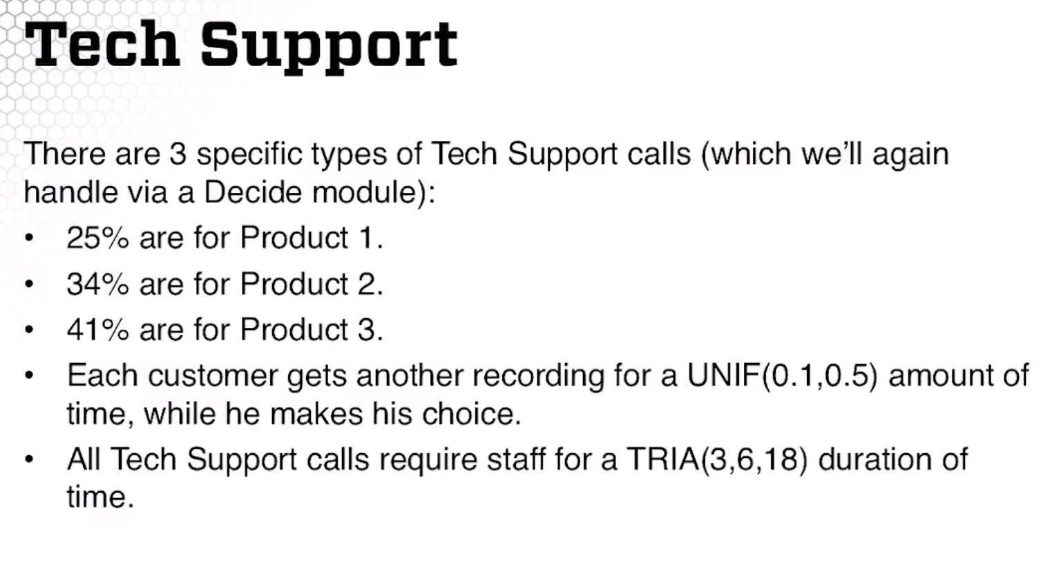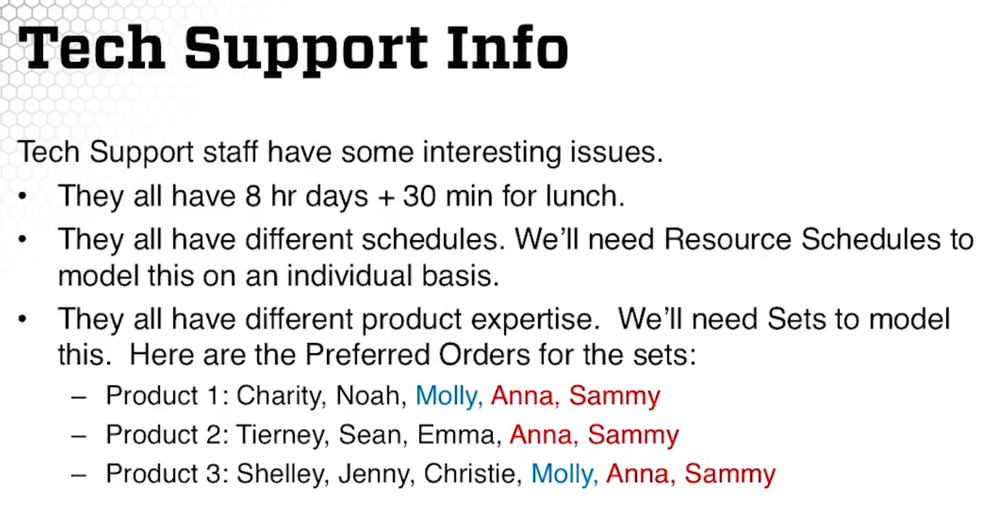

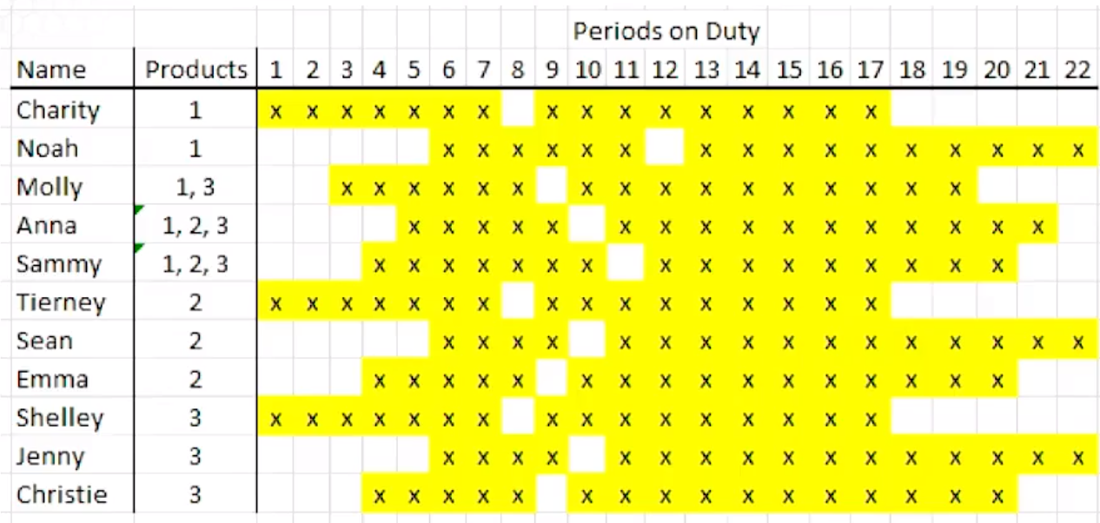

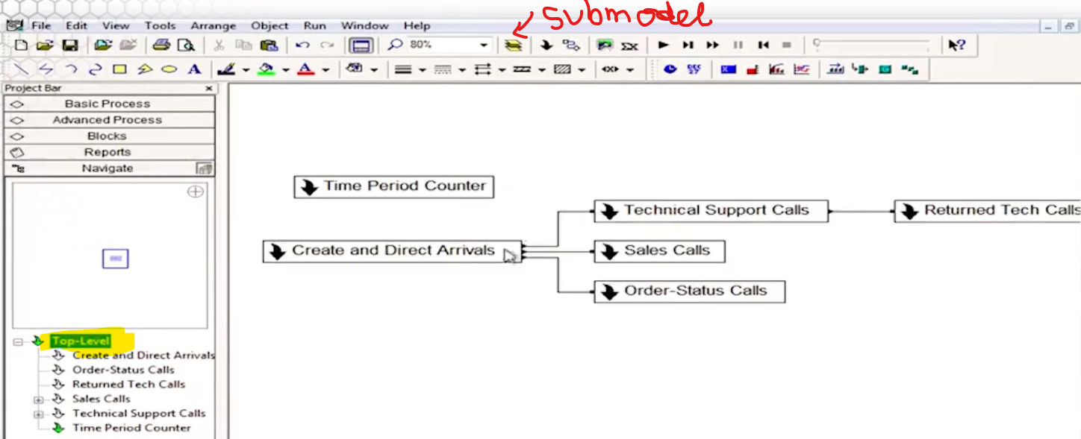

1. Time Period Counter_ First submodel: just to keep track of time using fake customer. Update every half an hour

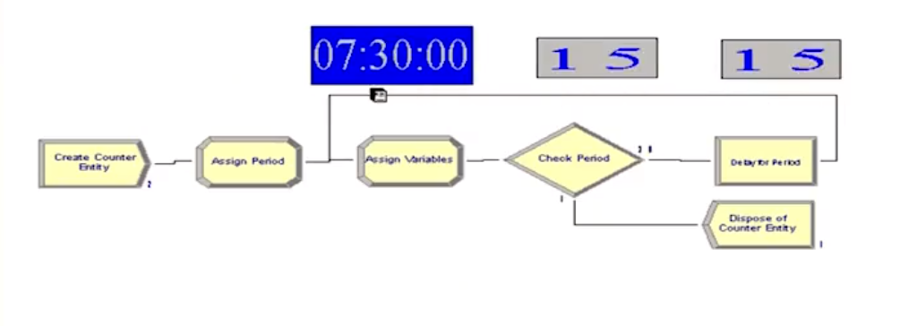

1. Create and Direct Arrivals. Queue here has capacity of 0. Seize 1 out of 26 phone lines. If they all busy, then queue line get to dispose. Once Decide module “ Determine Call type” assign by probabilities, then it gets an Assign module. And exist out of submodel.

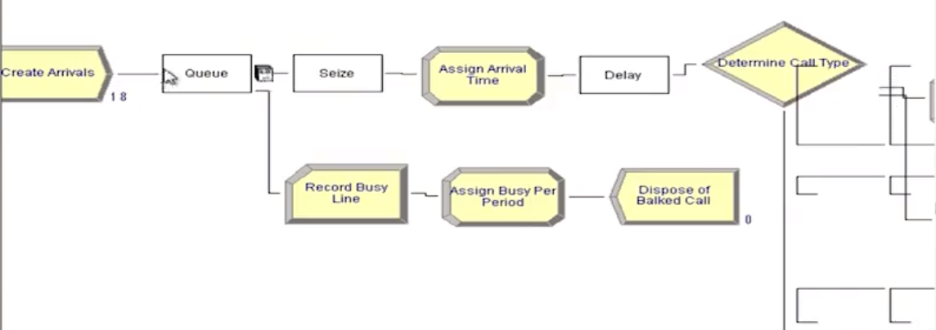 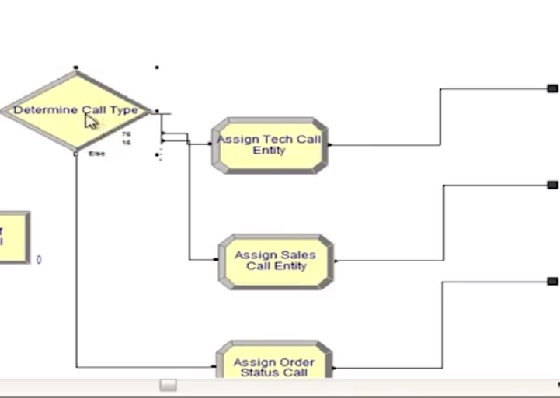

1. Sales Calls sub model: using advance process template to break Seize block from Release block. Trunk line is the resource Sieze for them from the previous submodel of creating arrival.

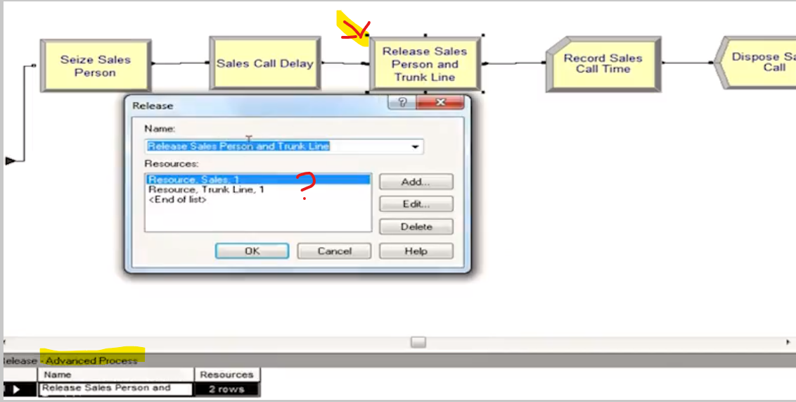

Here is the Resource spreadsheet.

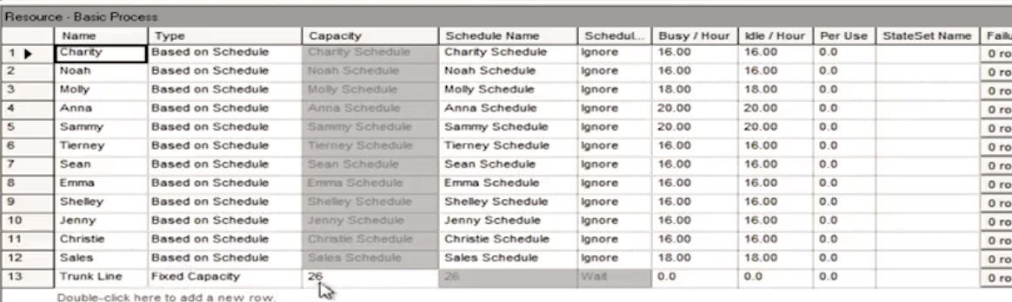Here is the schedule spreadsheets: Right click in duration to adjust the schedule.

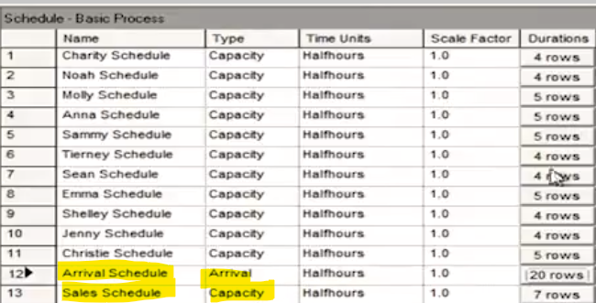

Set spreadsheet:

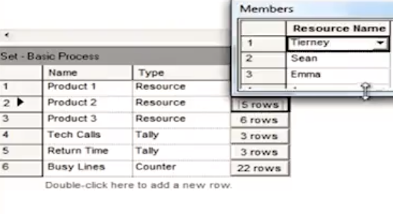

Submodel Technical Support call :

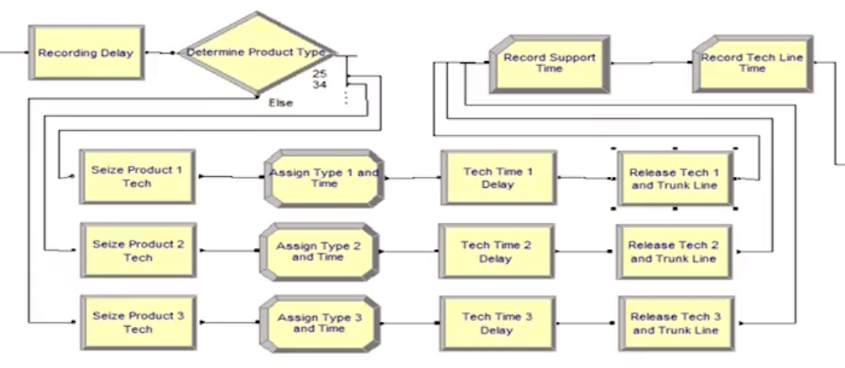

Seize product 1 tech: Seize 1 from Set called “ Product 1”, given the order how to select from the set “ preferred order” , store the agent as attribute “ tech agent index”

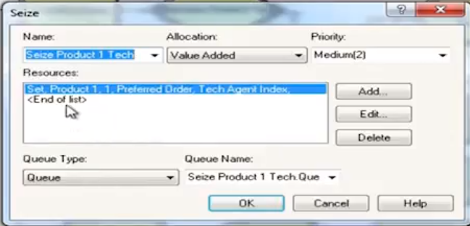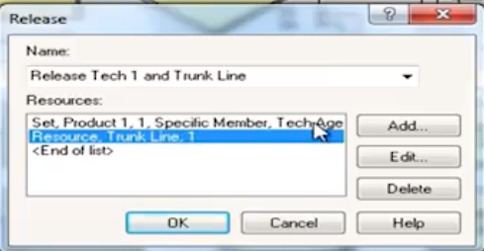

Tech time is based on Expression in the “ Expression” spreadsheet because we will use them on all 3 tech time delay. ( convenient)

Release : release from the set product 1, 1 agent based on the rule of “ specific member” given in the attribute of “ tech agent index” .

**Inventory Demo**

Inventory, unit cost, all other parameters are variables.

Inventory is decrementaed by demandas, incremented by order.

Interarrival times, demands, lead time are EXPRESSIONS from the Advanced Process Template

Accumulated costs are calculated in the STATISTICS spreadsheet in the Advanced Panel.

Daily inventory review is calculated by “ fake customer”

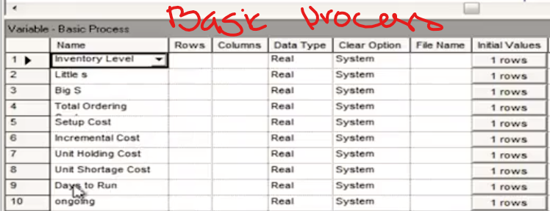 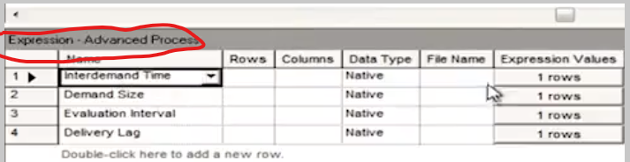

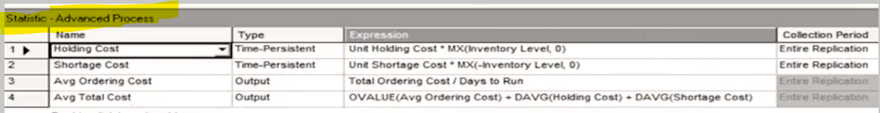

**Advanced Transfer Template**: for manufacturing system

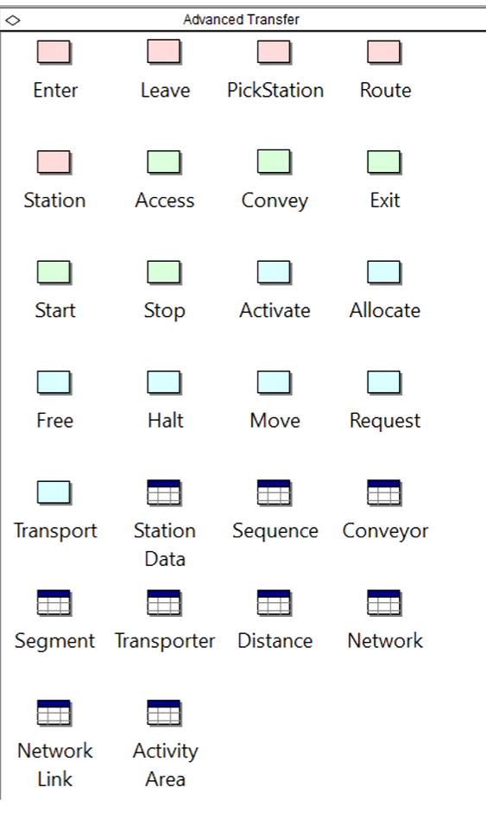

Station Module: somewhere you can go to , just the “ name”. Route module: tells you where you are going, similar to the Connector, except it takes time.

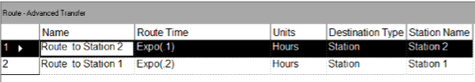

Enter & leave: kind of handling route but much more general way,

Sequences Spreadsheet: define a path for a customer through the system, from station to station. Each station migh have different service time distribution but you can define these at the sequence.

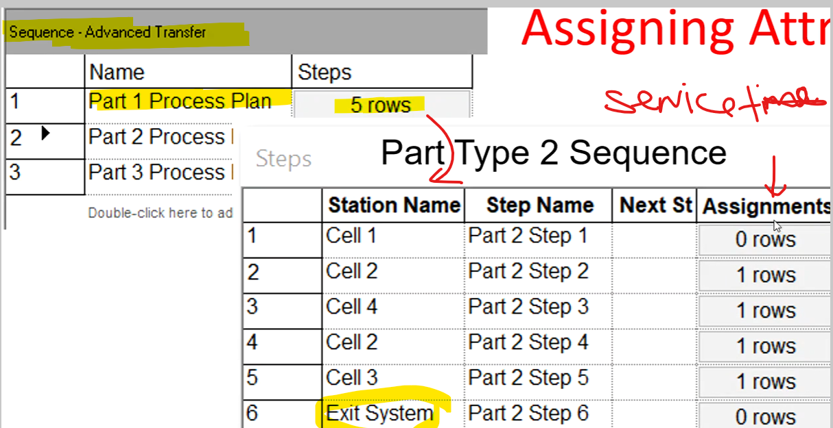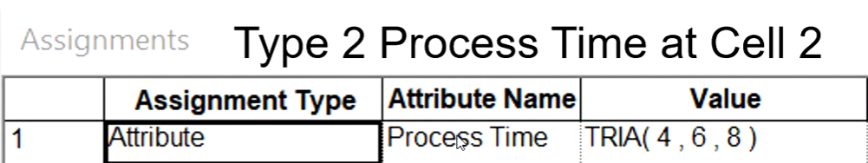 __> Cell 1 is defined as Expression spreadsheet in advanced process because it needs to know what type of part it is.

Transporter Spreadsheet: to add more transporter resource.

Advanced Sets spreadsheet inside Advanced Process panel: using for sets of sequences.

Really a vector of sequences: part1 process plan, part 2 process plan & part 3 process plan. Keep in the order.

